SYSTEM’S LAB – II

PRACTICAL 1

Name: Rishabh Jain

Branch & Sem: CSE 4th semester

Batch: A3

AIM: Design a Webpage for CSE department using HTML, also create your personal blog. Link both the pages.

Code:

1. Department.html

<html>

<head>

    <META http-equiv="Content-Type" content="text/html; charset=utf-8">

    <style></style>

    <link rel="stylesheet" href="./Prac1.css">

</head>

<body><u></u>

    <div>

        <img src="./header_main.png" alt="loading" width="1400px" height="300px">

        <h2> About Department</h2>

        <div class="m_vision">

            <h3><strong>Vision</strong></h3>

            <p>To continually improve the education environment, in order to develop graduates with strong academic and

                technical background needed to achieve distinction in the discipline. The excellence is expected in

                various domains like workforce, higher studies or lifelong learning. To strengthen links between

                industry through partnership and collaborative development works.</p>

        </div>

        <div class="m_sir">

            <h3><strong>Head of Department</strong></h3>

            <img src="./AvinashJAgrawal.jpg" alt="" class="m_yes">

            <h3>Dr. Avinash Agrawal Sir</h3>

        </div>

        <h3><strong>Under Graudate Programmes (UG)</strong></h3>

        <ul>

            <li>B.Tech. Computer Science &amp; Engineering </li>

            <li> B.Tech. Computer Science &amp; Engineering

                ( Artificial Intelligence &amp; Machine Learning )</li>

            <li> B.Tech. Computer Science &amp; Engineering

                ( Data Science )</li>

            <li> B.Tech. Computer Science &amp; Engineering

                ( Cyber Security )</li>

        </ul>

        <h3><strong>Post Graudate Programmes (PG)</strong></h3>

        <ul>

            <li> M.Tech. Computer Science &amp; Engineering</li>

        </ul>

        <br>

        <div class="m_features">

            <h3><strong>Salient features of Department</strong></h3>

            <p>

            <ul>

                <li>The Department of Computer Science &amp; Engineering was established in 2002, is well-equipped with

                    state-of-the-art infrastructure.</li>

                <li> The department established RCOEM-NVIDIA Center of Excellence for Artificial Intelligence, Machine

                    Learning, Deep Learning and Data Analytics that promotes high-end computing through Open Source

                    technologies and hosts NVIDIA DGX DL Workstation.</li>

                <li> The department has received a project grant of INR 1.03 crores in association with CSIR-Central

                    Institute of Mining and Fuel Research (CIMFR), Nagpur Research Centre (Fuel Sciences).</li>

                <li> The department laboratories are well equipped with hardware and firmware in line with the current

                    trends for development of projects in varied domains like, IoT, Robotics and networking.</li>

                <li> The department is involved in innovative practices that resulted in students winning awards for

                    projects of social relevance viz., USD 5000 in Data Streamr Challenge, USD 3500 in Biconomy

                    HackMoney and many more.</li>

                <li>

                    The department provides a platform to actively contribute to get through the challenges by CodeChef,

                    HackerRank, HackerEarth, Geeks Coding to name a few.

                    Students are encouraged to appear for GATE, CAT, GRE and other competitive examinations and opt for

                    higher studies from highly ranked universities in the field of Engineering and Management.</li>

                <li>

                    The department is involved in providing guidance to research interns facilitating student

                    publications in reputed journals.</li>

                <li>

                    The department also nurtures extra-curricular skills of students to get recognized at state,

                    national and inter-national levels.</li>

            </ul>

            </p>

        </div>

        <br>

        <h3><strong>Career Prospects</strong></h3>

        <p>There is large employment potential for Computer Science &amp; Engineering graduates in numerous sectors like

            Software Industries, IT Enabled Service firms, Research Sector and Communication industry. CSE graduates are

            offered employment from companies, namely, Goldman Sachs, ZS Associates, Amazon, Principal Global Services,

            Capgemini, LLC, Infosys, Informatica, VMware, BirlaSoft, TCS, Persistent Systems Ltd., BYJU&#39;s, Tata

            Consultancy Services, GlobalLogic India Pvt. Ltd., Infocepts, Accenture, L&amp;T, Merkle Sokrati, Softlink

            International and others with the average package being 4.81 lakhs. Dream companies like Goldman Sachs,

            Amazon and VMware offered compensation as high as 23 lakhs, 20 lakhs and 19.5 lakhs respectively. Graduates

            can seek opportunities to work in profiles like Software Developer, Application Developer, Enterprise

            Architect, Data Analyst, Database Administrator, Client Server Systems Manager etc. in these firms. In

            Government sector they can serve in reputed firms like NTPC, ONGC, ISRO, Banking Sector, Communication

            Industry like BSNL, MTNL etc. A few graduates have also excelled at Industry coding contests thereby

            grabbing placement in dream companies. Some graduates have also made efforts towards entrepreneurship and

            have successful startups, Tecture Business Solutions, PocketSavy, GreyOcean, SANICON, WebGile Solutions,

            BILogix, Ola Gate to name a few. The alumni of the department are pursuing higher studies at international

            and national universities of repute, namely, Illinois Institute of Technology Chicago, University of Texas,

            University of Southern California, North-Eastern University, Stevens Institute of Technology, New Jersey,

            IIT Bombay, IIIT Bangalore, XLRI Jamshedpur, SIBM Pune, IMT Ghaziabad and IIM Indore. Our alumni are working

            with software majors, viz., Rediff, Amazon, Microsoft, Yahoo, Informatica, JP Morgan, Intel, and Oracle with

            approximate annual packages of over INR 25 lakhs.</p>

        <br>

        <h3><strong>Industry Institute Interaction</strong></h3>

        <p>The Department has good industry interaction with Software industries, Government organization and Private

            Sectors around the region. The Memorandum of Understanding is signed for Student Projects, Faculty

            Trainings, and Research work. The industry offers problem definitions to pre-final and final year students

            for projects along with guidance. The final outcome in most of projects is integrated as part of product and

            utilized by industry.

            The industry offers training in recent trend and technology in the form of Open Elective courses. The guest

            lectures are organized by department by inviting industry experts in the areas of Mobility, Big Data, and

            Storage Management.

            To provide platform for students to demonstrate skill, department organize yearly technical event “Polaris”.

            This event is organized in association with Computer Society of India (CSI). The event witness large

            participation of students from various institutes across Nagpur region. The event is judged by industry

            experts.

            Every year an industry tour is organized by department to reputed Software Industries in India to help

            students to get acquainted with environment and working culture of software industry.</p>

        <br>

        <h3><strong>Some important links</strong></h3>

        <ul

            <li><a href="https://www.google.com/url?q=http://www.rknec.edu/Academics/Departments/ComputerScienceEnggUGProgramme.aspx&amp;source=gmail-html&amp;ust=1681883658628000&amp;usg=AOvVaw1GvisDoAhahqeQHUzes_6n"

                    target="_blank" rel="noreferrer">UG PROGRAMS</a></li>

            <li><a href="https://www.google.com/url?q=http://www.rknec.edu/Academics/Departments/ComputerScienceEngg-PG.aspx&amp;source=gmail-html&amp;ust=1681883658628000&amp;usg=AOvVaw05xGuVjfRUfI1-ahDSENTw"

                    target="_blank" rel="noreferrer">PG PROGRAMS</a></li>

            <li> <a href="https://www.google.com/url?q=http://www.rknec.edu/Academics/Departments/ComputerScienceEnggAchievements.aspx&amp;source=gmail-html&amp;ust=1681883658628000&amp;usg=AOvVaw2wbCmOb5-gC0_Q2X_pvx2q"

                    target="_blank" rel="noreferrer">ACHIEVEMENT</a></li>

            <li> <a href="https://www.google.com/url?q=http://www.rknec.edu/Faculty/SearchFaculty.aspx?d%3D3&amp;source=gmail-html&amp;ust=1681883658628000&amp;usg=AOvVaw1JA56iY_9QJuRg1NUT0VT1"

                    target="_blank" rel="noreferrer">FACULTY</a></li>

        </ul>

        <a href="./Blog.html" target="_blank" rel="noreferrer">Personal Blog Link</a>

    </div>

</body>

</html>

Department.css

body {

    background-color: rgb(254, 254, 254);

    color: rgb(16, 2, 2);

    margin-left: 30px;

}

a {

    color: rgb(20, 1, 1);

}

a:hover {

    color: rgb(0, 0, 0);

}

.yes {

    border-radius: 100%;

}

.sir {

    float: right;

    text-align: center;

}

.vision {

    text-align: left;

}

table,

th,

td {

    border: 1px solid rgb(22, 2, 2);

}

B)

Blog.html

<!DOCTYPE html>

<html>

<head>

    <meta http-equiv="Content-Type" content="text/html; charset=utf-8">

    <title>Rishabh Jain - Student</title>

    <link rel="stylesheet" href="./Blog.css">

</head>

<body>

    <div class="navbar">

        <ul>

            <li><a href="./skill.html">Skills</a></li>

            <li><a href="./about_me.html">About</a></li>

            <li><a href="./edu.html">Education</a></li>

            <li><a href="./contact.html">Contact</a></li>

        </ul>

    </div>

    <div class="main-content">

        <div class="left-side">

            <img src="./myphoto.jpg" alt="Photo" height="400" width="400">

            <h1>Hello, I'm Rishabh Jain</h1>

            <p>I'm a student pursuing my B.Tech in Computer Science and Engineering from Shri Ramdeobaba College of

                Engineering &amp; Management, Nagpur.</p>

        </div>

        <div class="right-side">

            <h2>About Me</h2>

            <p>Aside from my studies, I enjoy exploring new technologies and building projects. I'm particularly

                interested in web development and machine learning, and I'm always looking for new ways to apply my

                skills.</p>

        </div>

    </div>

</body>

</html>

Blog.css

*/* Global styles */*

body {

    background-color: black;

    color: white;

    margin: 0;

    padding: 0;

    font-family: Arial, sans-serif;

}

*/* Navbar styles */*

.navbar {

    background-color: #ffffff;

    display: flex;

    justify-content: center;

    align-items: center;

}

.navbar ul {

    list-style-type: none;

    margin: 0;

    padding: 0;

}

.navbar li {

    display: inline-block;

    margin-right: 20px;

}

.navbar a {

    text-decoration: none;

    color: rgb(0, 0, 0);

    font-size: 18px;

    font-weight: bold;

    padding: 10px;

    transition: all 0.2s ease-in-out;

}

.navbar a:hover {

    background-color: #ff5454;

}

*/* Main content styles */*

.main-content {

    display: flex;

    justify-content: space-between;

    align-items: center;

    padding: 190px;

}

.left-side {

    text-align: center;

}

.left-side img {

    border-radius: 50%;

    margin-bottom: 20px;

}

.left-side h1 {

    font-size: 36px;

    margin-bottom: 20px;

}

.left-side p {

    font-size: 18px;

}

.right-side {

    width: 40%;

}

.right-side h2 {

    font-size: 30px;

    margin-bottom: 20px;

}

.right-side p {

    font-size: 18px;

}

Contact.html

<!DOCTYPE html>

<html lang="en">

<head>

    <meta charset="UTF-8">

    <meta http-equiv="X-UA-Compatible" content="IE=edge">

    <meta name="viewport" content="width=device-width, initial-scale=1.0">

    <title>Contact</title>

    <link rel="stylesheet" href="contact.css">

</head>

<body>

    <div class="middle">

<p>

   <h1>Reach Me at</h1>

   <h3>jainra_1@rknec.edu</h3>

   <h3><img src="https://img.icons8.com/external-tanah-basah-glyph-tanah-basah/30/null/external-call-food-delivery-tanah-basah-glyph-tanah-basah.png"/>+91 7666137732</h3>

</p>

    </div>

    <div class="footer">

        <ul>

         <li><a href="https://github.com/R1shA3h"><img src="https://img.icons8.com/ios-filled/30/null/github.png"/></a></li>

            <li><a href="https://www.instagram.com/invites/contact/?i=1lef0dwufg0kt&utm_content=ne6d08o"><img src="https://img.icons8.com/ios-filled/30/null/instagram-new--v1.png"/></a></li>

            <li><a href="http://linkedin.com/in/rishabhanand-jain-5ba17322b"><img src="https://img.icons8.com/metro/30/null/linkedin.png"/></a></li>

        </ul>

    </div>

</body>

</html>

Contact.css

.middle

{

    width:100%;

    height:200px;

    background-color:rgb(246, 241, 241);

    margin-top: 100px;

    text-align: center;

    padding-top: 50px;

    color: rgb(18, 17, 17);

    font-family:'Gill Sans', 'Gill Sans MT', Calibri, 'Trebuchet MS', sans-serif;

}

ul{

    list-style-type: none;

}

li{

    display: inline;

    padding: 30px;

    float: right;

}

button{

    background-color: black;

    height: 30px;

    width: 100px;

    border-radius: 5px;

    text-align: center;

}

a{

    color: white;

    text-decoration: none;

}

a:hover

{

    color:white;

}

About.html

<!DOCTYPE html>

<html>

<head>

    <title>About Me</title>

    <link rel="stylesheet" href="./about_me.css">

    <style>

        img

        {

           height: 400px ;

        }

        div{

            text-align: center;

        }

    </style>

</head>

<body>

    <div>

        <h1>About Me</h1>

    <img src="./myphoto.jpg" alt="">

    <p>Hi there! My name is Rishabh Jain, and I'm a hardworking engineering student. Ever since I was a child, I've been

        fascinated by the way things work, and I've always loved taking things apart and putting them back together

        again. As I got older, I realized that engineering was the perfect field for me, as it allowed me to combine my

        love of problem-solving and innovation with my passion for science and technology.</p>

    <p>Currently, I'm studying B.Tech in Computer Science at RCOEM, and I'm always striving to learn as much

        as I can about the field. When I'm not in class or studying, you can usually find me working on personal

        engineering projects, or volunteering my time to help others in need. I'm a firm believer that engineering

        should be used to make the world a better place, and I'm always looking for ways to use my skills and knowledge

        to help others.</p>

    <p>In addition to my love of engineering, I'm also an avid reader and a sports player, and I enjoy reading various

        non-fiction & Self help books also I love to play football. I believe

        that it's important to have a well-rounded life outside of work and school, and I always make time for the

        things that bring me joy and fulfillment.</p>

    <p>I'm excited about the opportunities that lie ahead in my career, and I'm eager to see where my engineering

        journey takes me. Thank you for taking the time to learn a little bit about me, and I look forward to connecting

        with you!</p>

    </div>

</body>

</html>

About.css

body{

    background-color:rgb(10, 10, 10);

    color: white;

}

.right-side

{

width: 50%;

height: 800px;

float: right;

font-size: 20px;

font-family:'Gill Sans', 'Gill Sans MT', Calibri, 'Trebuchet MS', sans-serif;

line-height: 30px;

}

h1{

    font-family:'Gill Sans', 'Gill Sans MT', Calibri, 'Trebuchet MS', sans-serif;

    font-size:50px; ;

}

.left-side

{

    width: 50%;

    height: 800px;

    float: left;

    text-align: center;

    padding-top: 50px;

}

img{

    height: 500px;

    width: 400px;

}

.auth

{

    font-family:'Gill Sans', 'Gill Sans MT', Calibri, 'Trebuchet MS', sans-serif;

    font-size: 20px;

}

.head

{

    height: 150px;

    text-align: center;

    margin-top: 80px;

}

Skill.html

<!DOCTYPE html>

<html>

<head>

    <title>Skills</title>

    <style>

*/* Center page content */*

        body {

            display: flex;

            justify-content: center;

            align-items: center;

            flex-direction: column;

            background-color: black;

            color: aliceblue;

        }

*/* Style for skill container */*

        .skill {

            display: flex;

            flex-direction: column;

            align-items: center;

            margin: 20px;

        }

    </style>

</head>

<body>

    <h1>Skills</h1>

    <div class="skill">

        <h2>Graphic Design</h2>

        <img src="./grap_des.png" alt="Graphic Design">

    </div>

    <div class="skill">

        <h2>Web Development</h2>

        <img src="./webd.jpeg" alt="Web Development">

    </div>

    <div class="skill">

        <h2>Content Writing</h2>

        <img src="./con_writ.jpeg" alt="Content Writing">

    </div>

    <div class="skill">

        <h2>Social Media Marketing</h2>

        <img src="./soc_mark.png" alt="Social Media Marketing">

    </div>

    <div class="skill">

        <h2>Video Editing</h2>

        <img src="./video_edi.png" alt="Video Editing">

    </div>

    <div class="skill">

        <h2>Project Management</h2>

        <img src="./prod_manag.jpeg" alt="Project Management">

    </div>

</body>

</html>

Edu.html

<!DOCTYPE html>

<html lang="en">

<head>

    <meta charset="UTF-8">

    <meta http-equiv="X-UA-Compatible" content="IE=edge">

    <meta name="viewport" content="width=device-width, initial-scale=1.0">

    <title>Document</title>

    <link rel="stylesheet" href="./edu.css">

</head>

<body>

    <div class="head">

<h4>Education</h4>

    </div>

<div class="one">

    <p> <img src="https://img.icons8.com/color/48/null/star--v1.png"/>

        <h3>2021-2025</h3>

        <h2>University</h2>

        <h3>RCOEM</h3>

        <h3>CGPA(sem3):9.72</h3>

    </p>

</div>

<div class="two">

    <p><img src="https://img.icons8.com/color/48/null/star--v1.png"/><h3>2020-2021</h3>

        <h2>HSC</h2>

        <h3>Bhavan's B.P. Vidhya Mandir, S.K.N</h3>

        <h3>Percentage:91.5%</h3></p>

</div>

<div class="three">

    <p>    <img src="https://img.icons8.com/color/48/null/star--v1.png"/><h3>20218-2019</h3>

        <h2>SSC</h2>

        <h3>Bhavan's B.P. Vidhya Mandir, S.K.N</h3>

        <h3>Percentage:92%</h3></p>

</div>

</body>

</html>

Edu.css

body{

    background-color: black;

}

button{

    background-color: rgb(243, 237, 237);

    height: 30px;

    width: 100px;

border-radius: 5px;

    text-align: center;

    color: blue;

}

a{

    color: rgb(101, 66, 214);

    text-decoration: none;

}

a:hover

{

    color:white;

}

.one

{

    height:300px;

    color: white;

    width:50%;

    float: left;

    text-align: center;

}

.two

{

    height:300px;

   color: white;

    width:50%;

    float: right;

    text-align: center;

}

body{

    font-family: Cambria, Cochin, Georgia, Times, 'Times New Roman', serif;

    font-size: 20px;

    background-color:black;

    color: white;

}

h4{

    text-decoration: underline;

}

.three

{

    width: 100%;

    height: 80px;

    margin-top: 400px;

    text-align: center;

    color: white;

}

OUTPUT :

WEBSITE  
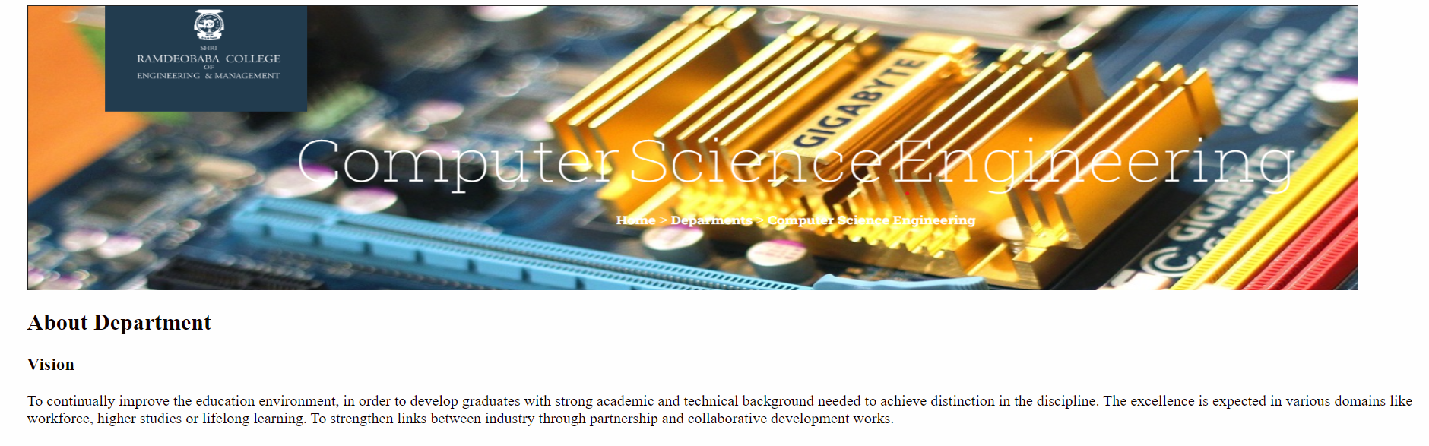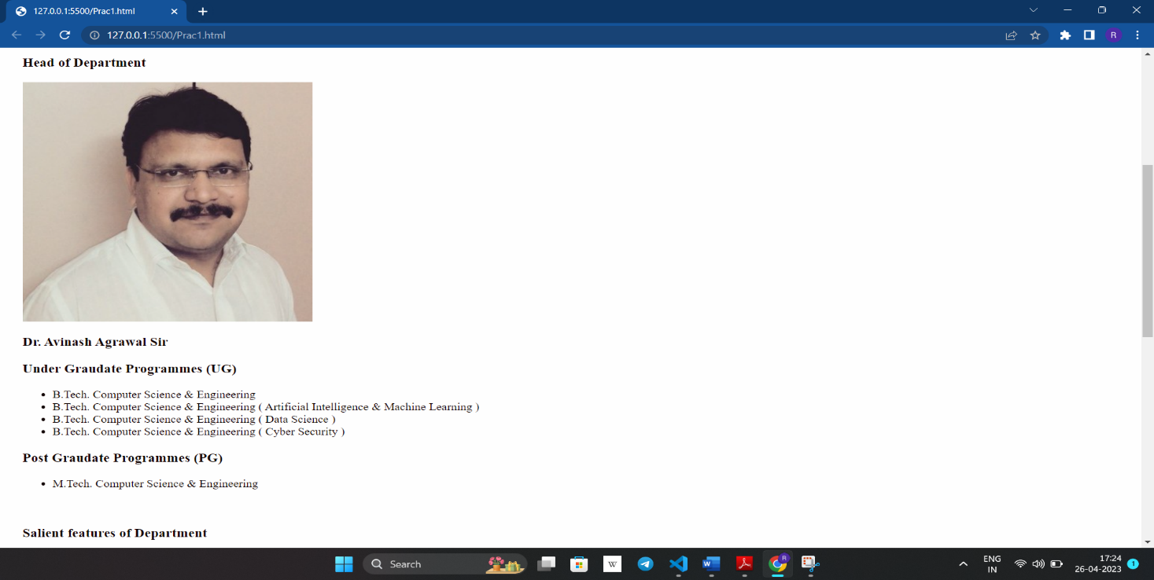

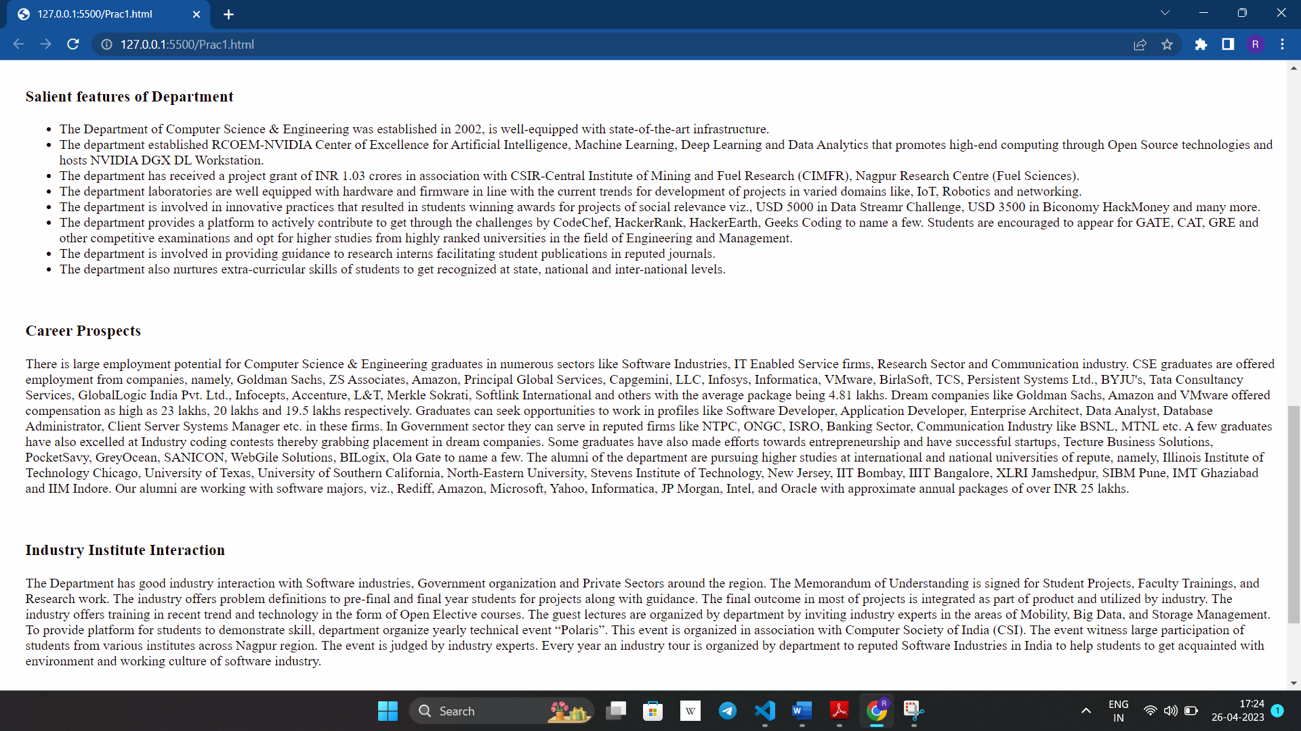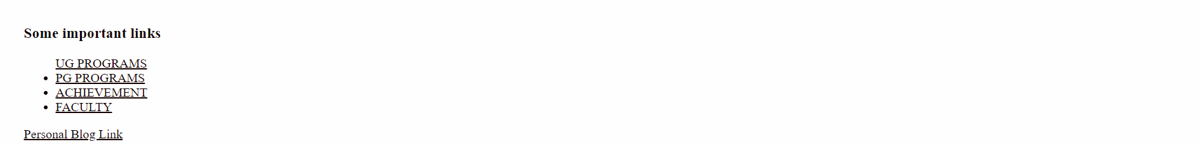

Personal Blog: